**CSS EXPERIMENT 1**

input_string = input("Enter a string: ").lower()

# Creating a dict

letter_number_map = {

    'a': 0, 'b': 1, 'c': 2, 'd': 3, 'e': 4, 'f': 5, 'g': 6, 'h': 7, 'i': 8, 'j': 9,

    'k': 10, 'l': 11, 'm': 12, 'n': 13, 'o': 14, 'p': 15, 'q': 16, 'r': 17, 's': 18,

    't': 19, 'u': 20, 'v': 21, 'w': 22, 'x': 23, 'y': 24, 'z': 25

}

key = int(input("Enter a key: "))

choice = int(input("1. Encrypt \n2. Decrypt: "))

if choice == 1:  # Encrypt

    encrypted_result = ""

    for letter in input_string:

        if letter.isalpha():

            number = letter_number_map[letter]

            encrypted_number = (number + key) % 26  # Adding the key to the letter number

            encrypted_letter = [k for k, v in letter_number_map.items() if v == encrypted_number][0] #k represents the letter and v represents the number.

            encrypted_result += encrypted_letter

    print("Given String: ",input_string)

    print("Encrypted result:", encrypted_result)

elif choice == 2:  # Decrypt

    decrypted_result = ""

    for letter in input_string:

        if letter.isalpha():

            number = letter_number_map[letter]

            decrypted_number = (number - key) % 26  # Subtracting the key from the letter number

            decrypted_letter = [k for k, v in letter_number_map.items() if v == decrypted_number][0]

            decrypted_result += decrypted_letter

    print("Given String: ",input_string)

    print("Decrypted result:", decrypted_result)

else:

    print("Invalid choice. Please enter 1 to encrypt or 2 to decrypt.")

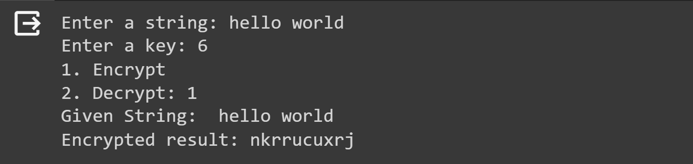

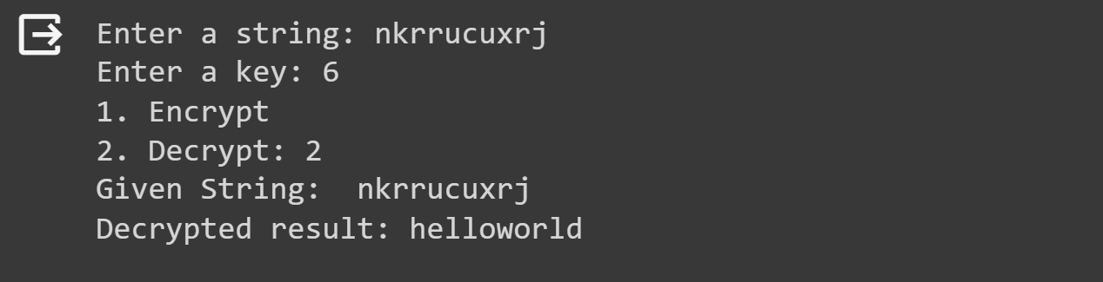

input_string = input("Enter a string: ").lower()

# Creating a dict

letter_number_map = {

    'a': 0, 'b': 1, 'c': 2, 'd': 3, 'e': 4, 'f': 5, 'g': 6, 'h': 7, 'i': 8, 'j': 9,

    'k': 10, 'l': 11, 'm': 12, 'n': 13, 'o': 14, 'p': 15, 'q': 16, 'r': 17, 's': 18,

    't': 19, 'u': 20, 'v': 21, 'w': 22, 'x': 23, 'y': 24, 'z': 25

}

key = int(input("Enter a key: "))

choice = int(input("1. Encrypt \n2. Decrypt: "))

if choice == 1:  # Encrypt

    encrypted_result = ""

    for letter in input_string:

        if letter.isalpha():

            number = letter_number_map[letter]

            encrypted_number = (number * key) % 26  # Multiplying the key with the letter number

            for k, v in letter_number_map.items():  #k represents the letter and v represents the number

                if v == encrypted_number:

                    encrypted_letter = k

                    break

            encrypted_result += encrypted_letter

    print("Given String: ", input_string)

    print("Encrypted result:", encrypted_result)

elif choice == 2:  # Decrypt

    decrypted_result = ""

    for letter in input_string:

        if letter.isalpha():

            number = letter_number_map[letter]

            # Finding the multiplicative inverse of the key

            inverse_key = 0

            for i in range(26):

                if (key * i) % 26 == 1:

                    inverse_key = i

                    break

            decrypted_number = (number * inverse_key) % 26  # Multiplying the letter number with the inverse of the key

            for k, v in letter_number_map.items():

                if v == decrypted_number:

                    decrypted_letter = k

                    break

            decrypted_result += decrypted_letter

    print("Given String: ", input_string)

    print("Decrypted result:", decrypted_result)

else:

    print("Invalid choice. Please enter 1 to encrypt or 2 to decrypt.")

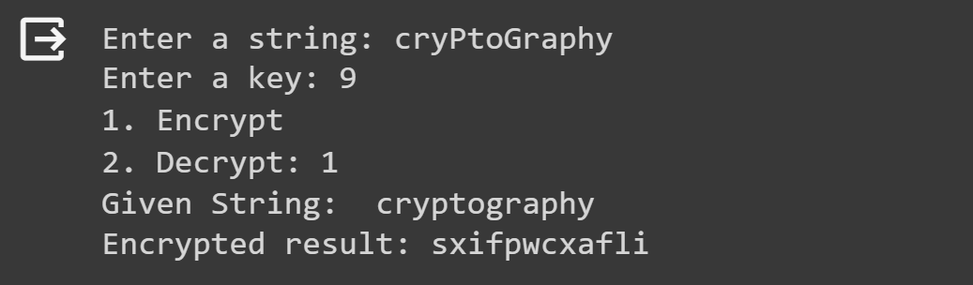

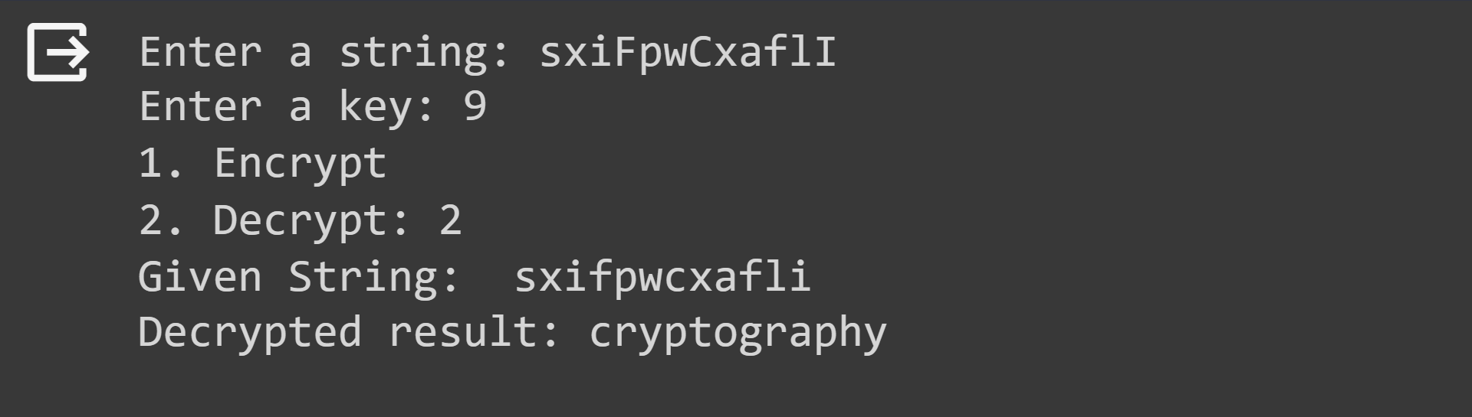

Row Transformation

input_string = input("Enter a string: ").lower()

string_without_spaces = input_string.replace(" ", "")

print("String without spaces:", string_without_spaces)

# Add 'x' at the end if the length is not even

if len(string_without_spaces) % 2 != 0:

    string_without_spaces += 'x'

print("Modified string:", string_without_spaces)

# Calculate the midpoint index

midpoint = len(string_without_spaces) // 2

# Divide the string into two parts

part1 = string_without_spaces[:midpoint]

part2 = string_without_spaces[midpoint:]

# Convert part1 and part2 into lists

list_part1 = list(part1)

list_part2 = list(part2)

result = ""

for i in range(0, len(list_part1), 2):

    result += f"{list_part1[i]} {list_part2[i]} "

    if i + 1 < len(list_part1):

        result += f"{list_part1[i + 1]} {list_part2[i + 1]} "

print("Encrypted string:", result)

# Create two strings s1 and s2 with even and odd indices from result

s1 = ''.join(result.split()[::2])

s2 = ''.join(result.split()[1::2])

# Create a variable decrypt by concatenating s1 and s2

decrypt = s1 + s2

print("Decrypted string:", decrypt)

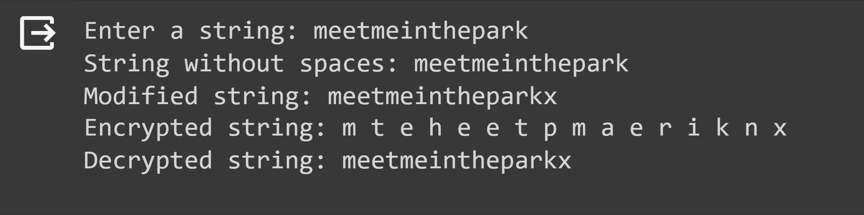

Keyed

input_string = input("Enter a string: ").lower()

string_without_spaces = input_string.replace(" ", "")

print("String without spaces:", string_without_spaces)

# Add 'x' at the end if the length is not even

if len(string_without_spaces) % 2 != 0:

    string_without_spaces += 'x'

print("Modified string:", string_without_spaces)

# Calculate the midpoint index

midpoint = len(string_without_spaces) // 2

# Put even index characters in list_part1 and odd index characters in list_part2

list_part1 = [part_list[i] for part_list in lists for i in range(0, midpoint, 2)]

list_part2 = [part_list[i] for part_list in lists for i in range(1, midpoint, 2)]

print("List part1 (even index characters):", list_part1)

print("List part2 (odd index characters):", list_part2)

encrypt = ''.join(list_part1 + list_part2)

print("Encrypted 'encrypt':", encrypt)

# Calculate the midpoint index

midpoint = len(encrypt) // 2

# Separate the string into two parts

part1 = encrypted_string[:midpoint]

part2 = encrypted_string[midpoint:]

# Interleave the characters from part1 and part2 to reconstruct the original string

decrypted_string = ''.join([char1 + char2 for char1, char2 in zip(part1, part2)])

# Print the decrypted string

print("Decrypted string:", decrypted_string)

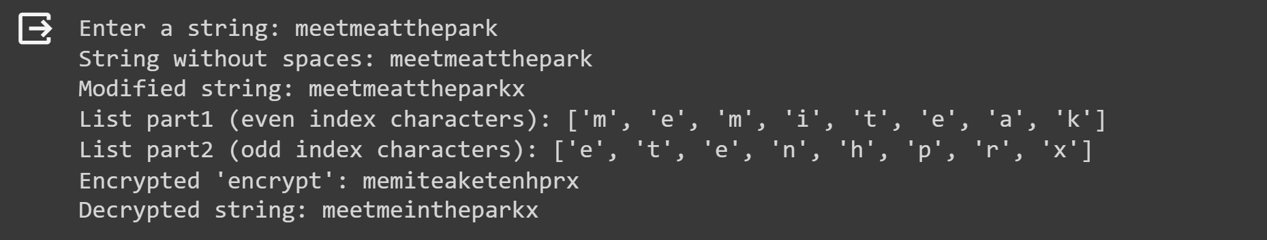

input_string = input("Enter a string: ").lower()

div = int(input("Enter a number: "))

# Get column order from the user

column_order = input("Enter a list of numbers separated by space: ")

numbers = [int(x) for x in column_order.split()]

string_without_spaces = input_string.replace(" ", "")

print("String without spaces:", string_without_spaces)

# Add 'x' at the end if the length is not evenly divisible by div

remainder = len(string_without_spaces) % div

if remainder != 0:

    string_without_spaces += 'x' * (div - remainder)

print("Modified string:", string_without_spaces)

# Calculate the number of rows in the matrix

num_rows = len(string_without_spaces) // div

# Create a matrix with div columns and num_rows rows

matrix = [[''] * div for _ in range(num_rows)]

# Insert characters of string_without_spaces into the matrix

index = 0

for row in range(num_rows):

    for col in range(div):

        if index < len(string_without_spaces):

            matrix[row][col] = string_without_spaces[index]

            index += 1

print("Matrix:")

for row in matrix:

    print(row)

# Use the user-provided column order

column_order = [col % div for col in numbers]

new_matrix = [[matrix[row][col] for col in column_order] for row in range(len(matrix))]

# Print the new matrix

print("New Matrix:")

for row in new_matrix:

    print(row)

encrypt = ''.join([''.join(row) for row in new_matrix])

# Print the encrypted string

print("Encrypted String:", encrypt)

